**(1)**

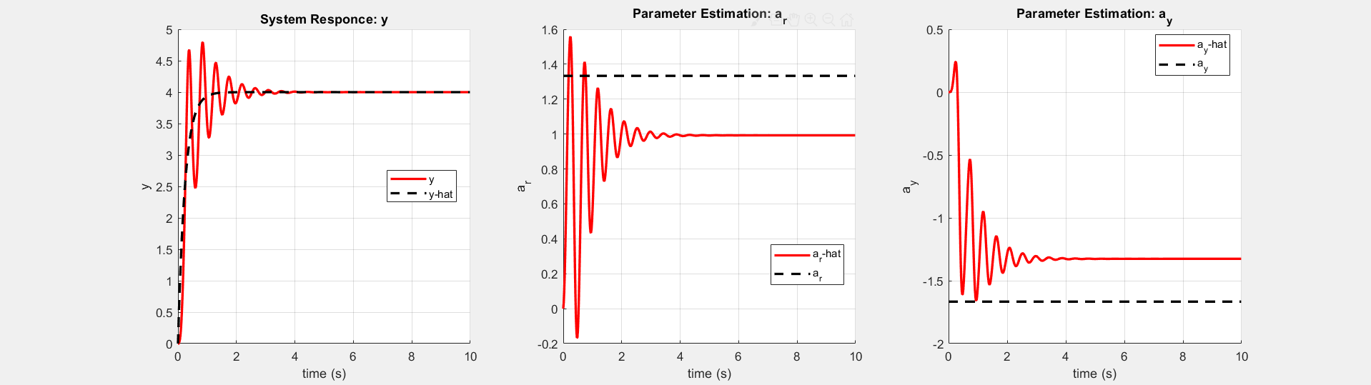

 

With a constant input , the estimates (, ) do not converge to the optimal parameter values (). The difference between the estimates and the optimal parameter values are equal in magnitude but opposite in direction as expected.

**(1)**

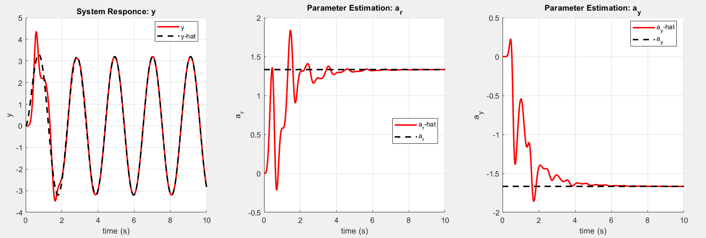

 

With a persistent excitation input , the estimates (, ) converge to the optimal parameter values ()…*I had to change from dt = 1/60 to dt = 1/6000 to get good convergence.*